NORTH BENGAL & SIKKIM
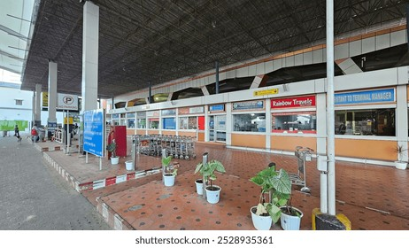

Circuit: Kalimpong – Gangatok – Darjeeling – Silliguri
ITINERARY:
DAY 01: | 13 MAY’26 | ARRIVAL BAGDGRA – KALIMPONG (77KMS, 02HRS)
Meeting and assistance upon arrival at Bagdogra Airport and drive to Kalimpong. Upon arrival check in hotel in at hotel Fortun Resort, Kalimpong

Dinner & Overnight stay at Hotel Fortune Resort
DAY 02: | 14 MAY’26 | KALIMPONG – GANGATOK (73KMS, 02HRS)
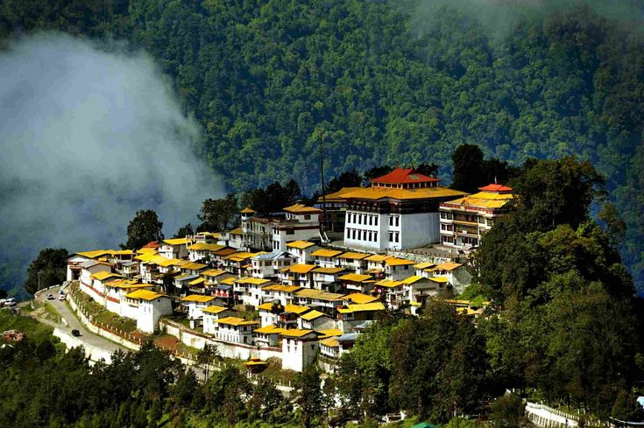
Morning breakfast in hotel – The Town is perched on a ridge above the Teesta River, it’s home to colonial-era buildings like MacFarlane Memorial Church, named after a Scottish missionary - South, the hilltop Durpin Monastery, or Zang Dhok Palri Phodang, contains sacred Buddhist scriptures - Drive for sight seeing - Kalimpong situated on the foothills of the Himalayas is a green destination at an altitude of 1243 meters / 4078 feet - It is a historical destinations with bustling market, colorful people and offers spectacular views of the Himalayan range - The scenic beauty on the way are beautiful and there are lot of shops selling antics and local handicraft worth buying – Drive for sightseeing tour through scenic road to Forest Museum (Closed On Thursday), Deolo / Dello Hill, Hanuman Mandir, Dr Graham Homes, Durbin Monastery, Mangaldham, Pine View or Simlar Nursery (Attractions are Cactus & Orchids)

After sightseeing drive to Gangtok. Upon arrival check in at Hotel Lemon Tree.

Dinner & Overnight stay at Hotel Lemon Tree, Gangtok
DAY 03: | 15 MAY’26 | GANGTOK
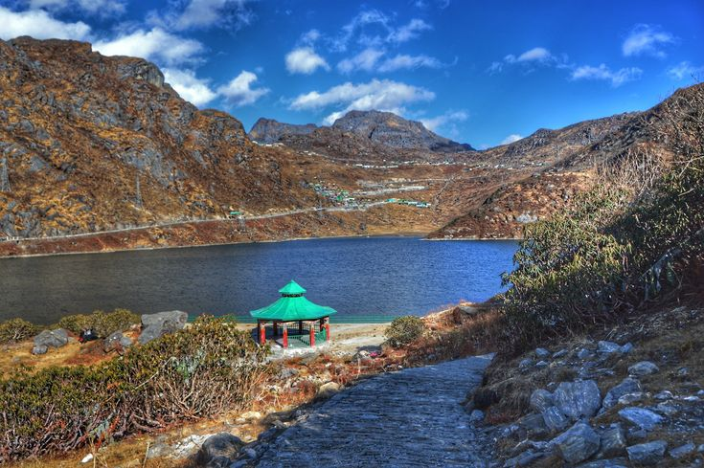
Morning after breakfast visit Tsomgo Lake: also known as Tsongmo Lake or Changgu Lake, is a glacial lake in Changu in the Gangtok district of the Indian state of Sikkim, some 40 kilometres (25 mi) from the capital Gangtok. Located at an elevation of 3,753 m (12,313 ft), the lake remains frozen during the winter season. The lake surface reflects different colours with change of seasons and is held in great reverence by the local Sikkimese people. Buddhist monks prognosticated after studying the changing colours of the lake. The lake is the venue for the Guru Purnima festival which is also the Raksha Bandhan festival when the faith healers known as Jhakris of Sikkim assemble at the lake area to derive benefits from the healing qualities of the lake waters. Alpine forests cover the catchment of the lake. After the winter season ends in middle of May, the periphery of lake has scenic blooms of flower species of rhododendrons (the state tree of Sikkim), primulas, blue and yellow poppies, irises and so forth. Also seen in the precincts of the lake are several species of birds including Brahminy ducks. Wildlife seen includes the red panda

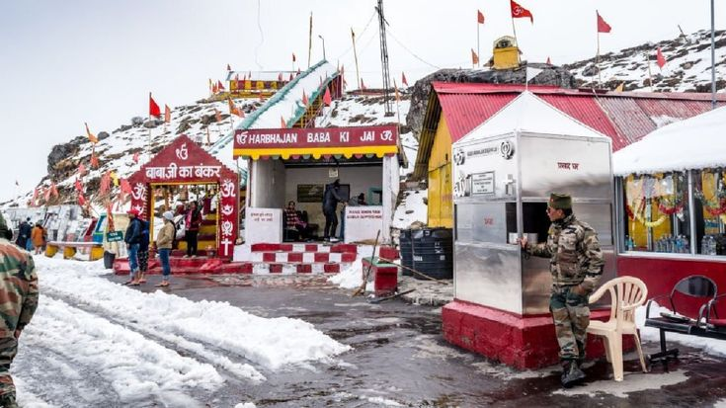
Afternoon excursion to Baba Mandir: High in the Eastern Himalayas, amidst rugged terrain and freezing winds, lies a shrine unlike any other in India—the Baba Harbhajan Singh Mandir, lovingly known as Baba Mandir. Located between Nathula Pass and Jelep La in Sikkim at an altitude of around 13,123 feet, this sacred site isn’t dedicated to a deity or sage, but to a soldier. Born in Punjab in 1946, Harbhajan Singh enlisted in the Indian Army in 1966 and served with the 23rd Punjab Regiment. In 1968, while escorting a mule column in the treacherous Nathula region, he tragically lost his life when he slipped and drowned in a glacier stream during heavy rains. What followed, however, was no ordinary remembrance. Days after his disappearance, soldiers reported dreams in which Baba revealed the location of his own body and asked for a memorial to be built in his honor. True to their faith, his fellow soldiers recovered the body and constructed a shrine near the very spot. Thus began the legend of Baba Harbhajan Singh—the soldier saint who is still believed to roam the mountains, protecting his comrades in uniform.

Dinner & Overnight stay at Lemon Tree, Gangtok
DAY 04: | 16 MAY’26| GANGTOK
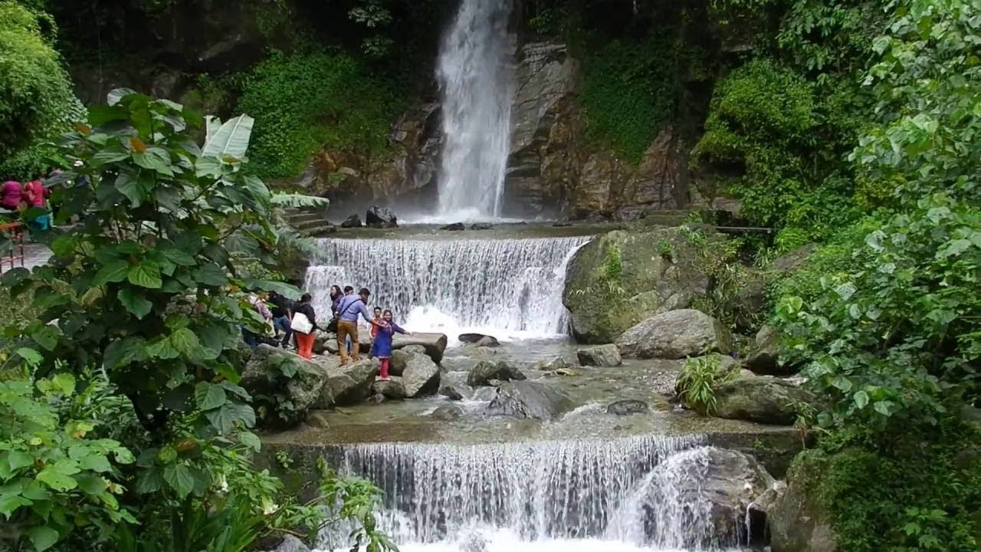
Morning after breakfast proceed for full day sightseeing tour of Gangtok visiting Jhakri Water Fall, The waterfalls are a breath-taking site that flows down to create a mesmerising pool, Do-rul Chhorten, Namgyal Research Institute of Tibetology (Closed on Sunday), Directorate of Handicraft & Handloom (Closed on Sunday) Orchid Flower Show, Tashi View point, Excellent viewing point of Gangtok city and Mount Kanchanzonga,Ropeway Cable car and Gunesh Tok, offers its visitors with extensive views of the enormous Kanchenjunga mountain ranges if the weather are clear.

Dinner & Overnight stay at Hotel Lemon Tree, Gangtok

DAY 04: | 17 MAY’26| GANGTOK – DARJEELING (95KMS, 03HRS)
Morning after breakfast drive to Darjeeling. Upon arrival check in at hotel Orsino Spa Resort.

Rest of the day free for relaxation / explore surrounding.

Overnight stay at Hotel Orsino Spa Resort, Darjeeling.

DAY 05: | 18 MAY’26| DARJEELING
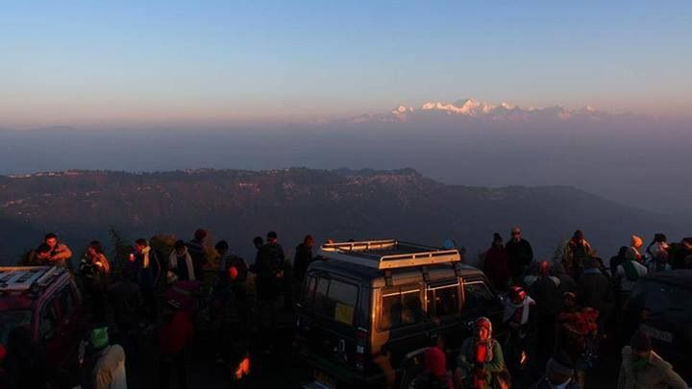
Take an early morning excursion to Tiger Hill (2590 m) to view the sunrise and its reflection on Kanchenjunga and Mt. Everest in their majestic glory. Later drive to Ghoom (8 km away, altitude 2550 m) to see the important Yiga-Choling gompa, a Yellow Hat sect Buddhist monastery. The 19th century gompa, one of the oldest in the area, enshrines an enormous gilded statue of the Maitreya Buddha and also houses valuable Tibetan manuscripts.
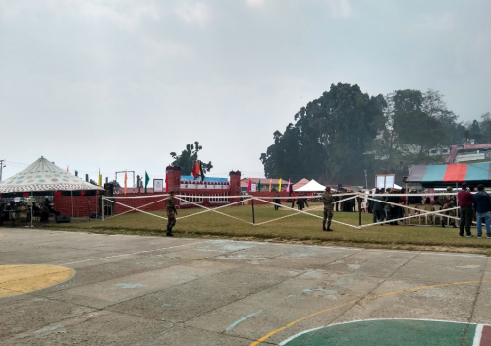
Afternoon proceed for sightseeing tour of Darjeeling visiting the Lebong Race Course, once the highest in the world. Visit the Himalayan Mountaineering Institute and Everest Museum and the house of Tenzing Norgay, who shared the first climb of Mt. Everest in 1953.

Dinner & Overnight stay at Hotel Orsino Spa & Resort, Darjeeling
DAY 06: | 19 MAY’26| DARJEELING – SILLIGURI (62KMS, 02HRS)
Morning after breakfast drive to Silliguri enroot visiting Mirik: is a small town and a Notified Area of Darjeeling district in the state of West Bengal, India. It is the headquarters of the Mirik subdivision. The name Mirik comes from the Lepcha words Mir-Yok meaning "place burnt by fire. Mirik Bazar began a commercial centre of the region where people from the surrounding villages and tea gardens came to trade and buy their necessities. The present lake area was a marshland with thick growth of sweet flag (Acorus calamus, locally called bojho). A playground stood in the present garden area where the British officers played polo.

Continue drive to Silliguri. Upon arrival check in at hotel Lemon Tree, Silliguri.

Dinner & Overnight stay at Lemon Tree, Silliguri

DAY 07: | 20 May’26| SILLIGURI – BAGDOGRA AIRPORT (14KMS, 33MNTS)
On time transfer from Siliguri to Bagdogra airport to board the flight for the onward destination.

TOUR COST
CATEGORY | COST PER PERSON
Total cost based on 4 star hotel for two paying pax | INR 72625 PP
Cost for 8yrs child without bed (Sharing bed with parents) | INR 14,062 Nett

City | Hotel | Date | Room | Night
Kalimpong | Fortune Resort or similar | 13 – 14 May’26 | Premium Room | 01 Night
Gangtok | Lemon Tree or similar | 14 – 17 May’26 | Superior Room | 03 Night
Darjeeling | Orsino Spa Resort or similar | 17 – 19 May’26 | Premium Room | 02 Night
Siliguri | Lemon Tree | 19 – 20 May’26 | Superior Room | 01 Night
Total number of nights |  |  |  | 07 Nights

Our prices include:

Accommodation as mentioned in Hotel Section

Transport as per program on Point to Point basis and not on disposal basis

Assistance by our rep at Bagdogra Airport

Our prices do not include:

Any meals other than those mentioned above.

Services of guide

Entrance fees to monuments

Any Airfare/ Train Tickets/ Nathula Pass / Toy Train

Any portage at airports and hotels, Camera/Videographer Charges, Guide charges, Entrances & Incidentals, Tips, Insurance, Wine, Mineral Water, Telephone Charges and all items of personal nature.

Any services not specifically mentioned in the inclusions.

Expenses caused by factors beyond our control like rail and flight delays, roadblocks, Landslide, vehicle mal-functions, political disturbances etc.

